Lab 2 - Implementing Decision Instructions in RISC V Assembly Language

Name: Aqsa Muneer, Maleeha Khan | Student ID: am10527, mk09991

Task 1:

Code:
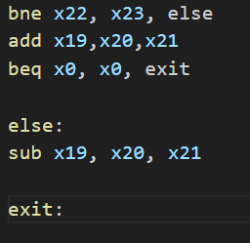

Results:
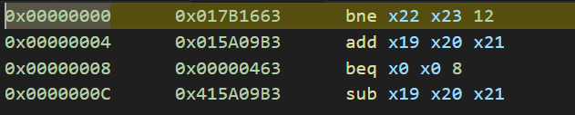
For bne:
Machine code: 0000 0001 0111 1011 0001 0110 0110 0011
Opcode: 1100011, funct3: 001, rs1: 10110, rs2: 11011, imm: 0 0 00000 01100

For beq:
Machine Code: 0000 0000 0000 0000 0000 0100 0110 0011
Opcode: 1100011, funct3: 000, rs1 : 00000, rs2 : 00000, imm: 0 0 000000 01000
The opcode refers to the broad category of instruction, aka the conditional branch instructions. The funct3 code tells us the exact operation being performed. Rs1 and rs2 are the source registers and imm refers to the number of instructions that are jumped to reach the label that it refers if the conditional branch is true.

Task 2:
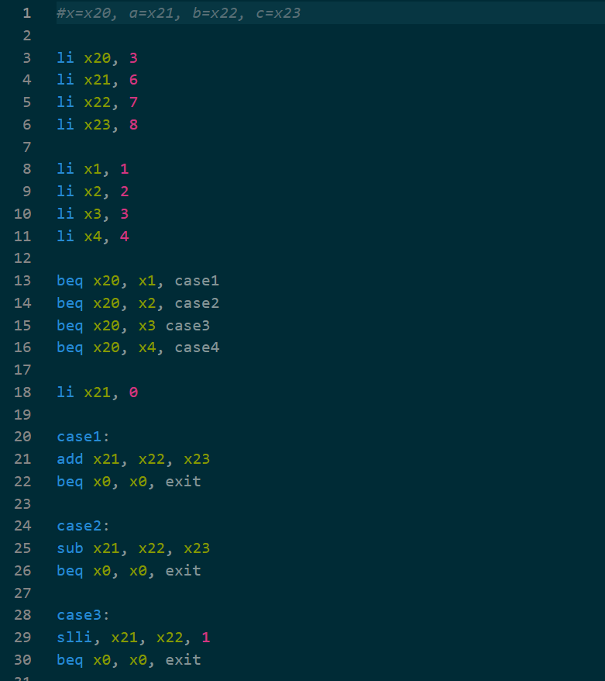
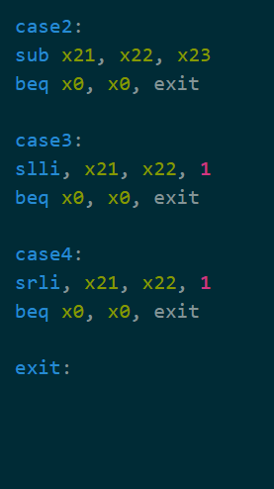

Code:

Results:
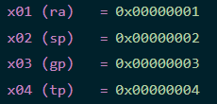
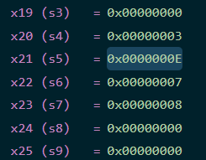

Task 3:

Code:
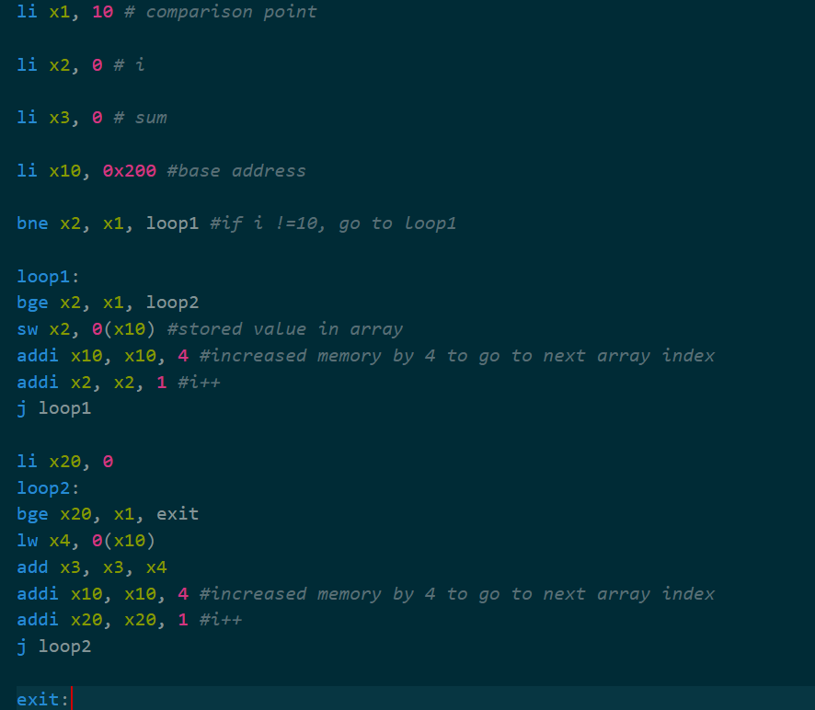

Results:
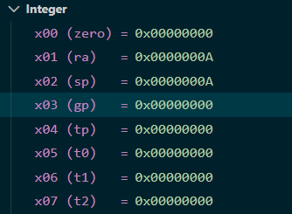
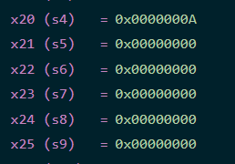

Task 4:

Code:

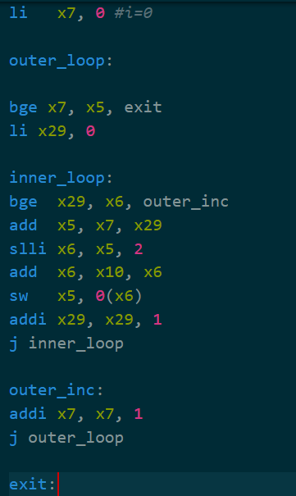
Results:

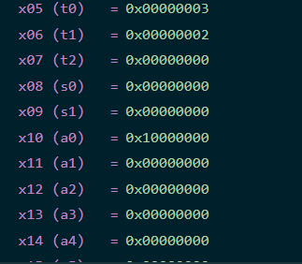
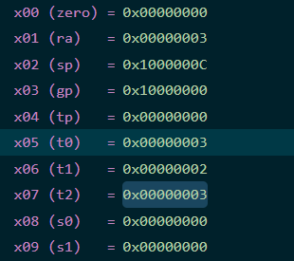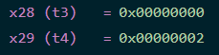

Assessment Rubric
Lab 2 - Implementing Decision Instructions in RISC V Assembly Language

Name | Student ID: | Section:

Points Distribution:

 | Task No. | LR 2 (Code) | LR 5 (Results)
In-Lab | Task 1 | - | /5
 | Task 2 | /10 | /10
 | Task 3 | /15 | /10
 | Task 4 | /20 | /10
Total Points: 100 |  | /45 | /35
CLO Mapped |  | CLO 2

Affective Domain Rubric |  | Points | CLO Mapped
AR7 | Report Submission & Git Upload | /10 & /10 | CLO 2

CLO | Total Points | Points Obtained
2 | 100
Total | 100

